TITLE OF PAPER
A.B. Presenting Author¹, C. Co-author¹, D.E. Co-author²
¹University, Country, Affiliation
²University, Country, Affiliation
E-mail address of the presenting author
This is an abstract sample. Text should be written in English and submitted in Microsoft Word format (*.doc or *.docx). Any other files will not be considered. The total file size should not exceed 2.5 MB.
Paper size: A4. Margins: 2.0 cm on the top, bottom and right side, 2.5 cm on the left side.
Font: Times New Roman, 12 pt; line spacing: single; no extra spacing between paragraphs.
Abstract size: no more than one page including tables and illustrations, if any.
The abstract title must contain no more than 150 characters, including spaces.
For each affiliation the name of the organization and the state should be indicated without address. The presenting author's E-mail address should be included on the next line.
No header or footer is allowed. Figures should be of good quality and resolution not less than 300 dpi. Figures and Tables should be embedded in the main text file; the total volume of Graphics and Tables should not exceed 1/3 of text volume. Do not wrap the text around any of the graphics. Figures and Tables must have captions.

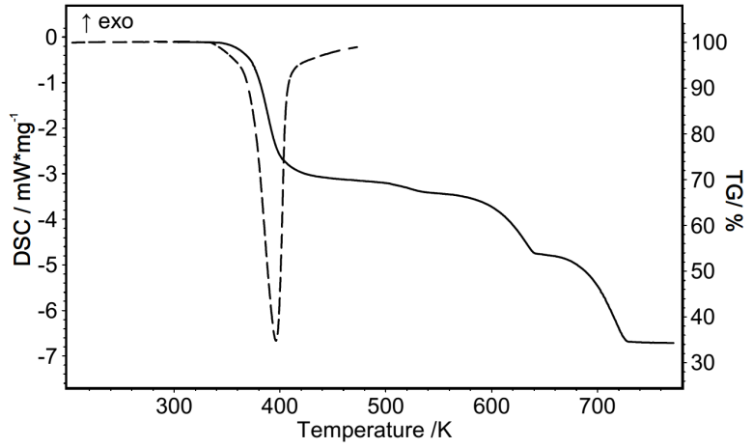
Figure 1. Figure caption.

Acknowledgements must be located at the end of the abstract, just before the references.
Acknowledgements The financial support of …
[1] A. Name, B. Name and C. Name, Journal Title, 2015, 68, 125.
[2] A. Name (or Editor), Title of the book, 2000, Chapter, page(s). Publisher, City, Country.

